|  |  |
| --- | --- |
| **Title:** | **Window Lifter**  **State Machines System Design** |

|  |  |  |  |  |
| --- | --- | --- | --- | --- |
| **History** | | | | |
| **Issue status**  (Index) | **Maturity/Date**  (draft/invalid/valid)  (dd-mmm-yyyy) | **Author**  Department | **Check/Release**  Department | **Description** |
| 1.0 | Draft  04-0ct-09 | Miguel Garcia | Miguel Garcia | Creation of the document |
| 2.0 | 21-Jul-15 | Misael AD Kevin CG | Diego Flores David Rosales | State Machines system design document |

**Table of Contents**

1 Purpose 5

2 Definitions and abbreviations 5

3 Realization constraints and targets 6

4 SW Conceptual design 6

5 SW Component internal breakdown 11

5.1 Window Lifter State Machine Functional Decomposition 11

5.2 Button State Machine Functional Decomposition 12

Function Description and Dynamic Behavior 12

*5.3* Function windowlifter_UP(void) 13

*5.4* Function windowlifter_DOWN(void) 13

*5.5* Function windowlifter_PINCH(void) 13

*5.6* Function Switch_Read(T_UBYTE input) 14

*5.7* Function Switch_Combination(void) 14

# Purpose

State Machines Design System Document. This document has been created to show the design process of the button state machine, window state machine, and their internal structure.

# Definitions and abbreviations

**Definitions**

|  |
| --- |
|  |

**Abbreviations**

EWCM Electronic Window Control Module

SchM Scheduler Module

**References**

|  |  |  |  |  |  |
| --- | --- | --- | --- | --- | --- |
| **N°** | | **Document name** | |  | |
| 1 | | [Window lifter requirements](../Window%20lifter%20requirements.docx) | |  | |
| *2* | | [*DSD System*](DSD_System.docx) | |  | |
| 3 | | [*Traceability matrix*](../1.0%20Requirements/Traceability%20Matrix%20Template.xlsm) | |  | |
| 4 | | [Review document](../EWCM%20Review%20Document.docx) | |  | |
|  | |  | |  | |
|  | |  | |  | |
|  | |  | |  | |
|  | |  | |  | |

# Realization constraints and targets

The desired goals for this system are:

* Read inputs correctly and predictably.
* Achieve a modular design.

# SW Conceptual design

**WINDOW LIFTER STATE MACHINE**

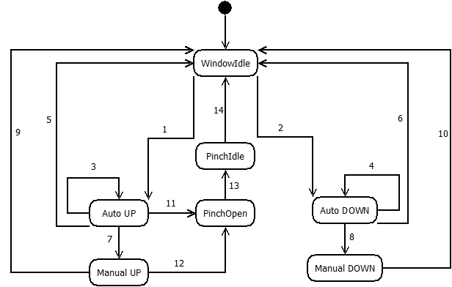

|  |  |  |
| --- | --- | --- |
| **TRANSITION** | **CONDITION** | **ACTION** |
| 1 | Valid button UP pressed. | Initialize Auto UP. |
| 2 | Valid button DOWN pressed. | Initialize Auto DOWN. |
| 3 | No input detected and button UP pressed < 500ms | Stay in Auto UP |
| 4 | No input detected and button DOWN pressed < 500ms | Stay in Auto DOWN |
| 5 | If window closed, or other input by user detected. | State |
| 6 | If window opened, or other input by user detected. | Return to Idle. |
| 7 | If button UP pressed >500 ms. | Initialize Manual UP. |
| 8 | If button DOWN pressed >500ms | Initialize Manual DOWN |
| 9 | If window closed, or button UP released. | Return to Idle. |
| 10 | If window opened, or button DOWN released. | Return to Idle. |
| 11 | If Pinch signal==SET | Pinch Open |
| 12 | If Pinch signal==SET | Pinch Open |
| 13 | If window opened. | Go to Pinch Idle, ignore inputs for 5 seconds. |
| 14 | If 5 seconds passed. | Go to Window Idle, clear flags. |

|  |  |
| --- | --- |
| **STATE** | **DESCRIPTION** |
| Window Idle | System is running background tasks, waiting for inputs. |
| Auto UP | Increments window position until closed. |
| Auto DOWN | Decrements window position until opened. |
| Manual UP | Increments window position until closed or button released. |
| Manual DOWN | Increments window position until opened or button released. |
| Pinch Open | Stops movement and gets window to opened position. |
| Pinch Idle | Ignores inputs for 5 seconds. |

* ***AUTO MODE SEQUENCE DIAGRAM***

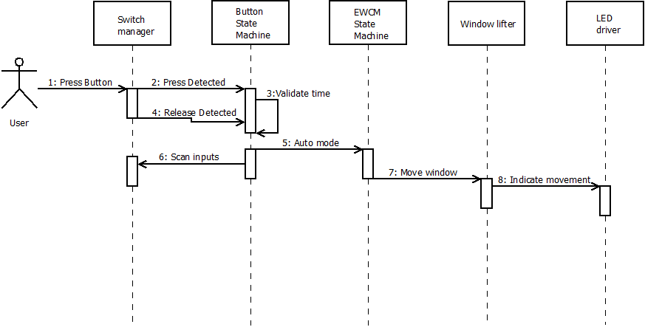

* ***MANUAL MODE SEQUENCE DIAGRAM***

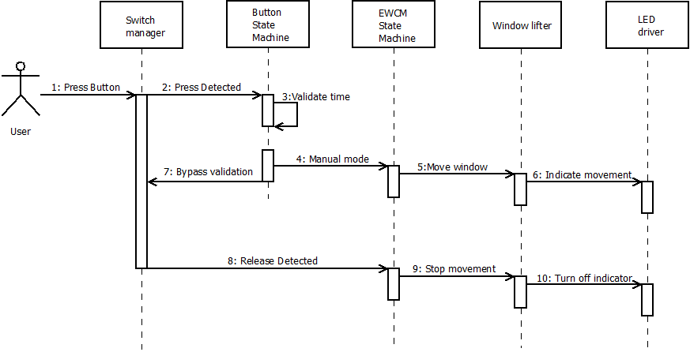

* ***ANTI-PINCH SEQUENCE DIAGRAM***

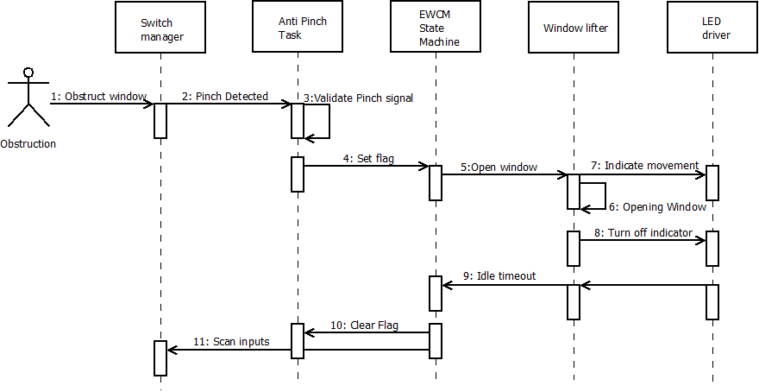

**BUTTON STATE MACHINE**

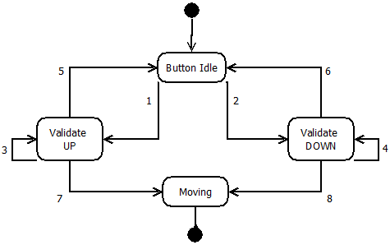

|  |  |  |
| --- | --- | --- |
| **TRANSITION** | **CONDITION** | **ACTION** |
| 1 | Button UP pressed and time>10ms. | Validate UP |
| 2 | Button DOWN pressed and time>10ms | Validate Down |
| 3 | Time<500ms and button UP still pressed. | Stay in Validate UP |
| 4 | Time<500ms and button DOWN still pressed. | Stay in Validate DOWN |
| 5 | Time<500ms and button UP released. | Go to Button Idle. |
| 6 | Time<500ms and button DOWN released. | Go to Button Idle. |
| 7 | Time>500ms and button UP still pressed. | Moving |
| 8 | Time>500ms and button DOWN still pressed. | Moving |

|  |  |
| --- | --- |
| **STATE** | **DESCRIPTION** |
| Button Idle | System scans for inputs. |
| Validate UP | Validate that button UP was pressed. |
| Validate DOWN | Validate that button DOWN was pressed. |
| Moving | Indicates that window is moving in manual mode, regardless of direction. |

# SW Component internal breakdown

## Window Lifter State Machine Functional Decomposition

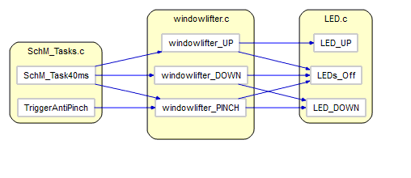

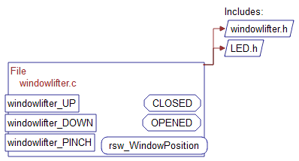

## Button State Machine Functional Decomposition

## C:\Users\EDGAR\Desktop\DiagramasUnderstand\EWCM\Switch\Switch.c\ClusterCallButterfly-switch-c.png

## C:\Users\EDGAR\Desktop\DiagramasUnderstand\EWCM\Switch\Switch.c\Declaration-switch-c.pngFunction Description and Dynamic Behavior

**Window Lifter State Machine Functions**

## Function windowlifter_UP(void)

|  |  |
| --- | --- |
| **Description** | Increments window position. |
| **Parameter 1** | *Void* |
| **Parameter 2..n** | *Void* |
| **Return Value** | *None* |
| **Precondition** | *None* |
| **Post condition** | *None* |
| **Error Conditions** | *None* |

**Dynamic Behavior**

## Function windowlifter_DOWN(void)

|  |  |
| --- | --- |
| **Description** | *Increments window position.* |
| **Parameter 1** | Void |
| **Parameter 2..n** | *Void* |
| **Return Value** | *None* |
| **Precondition** | *None* |
| **Post condition** | *When window opened, change to Idle.* |
| **Error Conditions** | *None* |

**Dynamic Behavior**

## Function windowlifter_PINCH(void)

|  |  |
| --- | --- |
| **Description** | *Stop movement UP, decrement window position until opened.* |
| **Parameter 1** | Void |
| **Parameter 2..n** | *Void* |
| **Return Value** | *None* |
| **Precondition** | *None* |
| **Post condition** | *When window opened, send to Pinch Idle.* |
| **Error Conditions** | *None* |

**Dynamic Behavior**

**Button State Machine Functions**

## Function Switch_Read(T_UBYTE input)

|  |  |
| --- | --- |
| **Description** | *Retrieves GPDI required value.* |
| **Parameter 1** | Void |
| **Parameter 2..n** | *Void* |
| **Return Value** | *T_UBYTE* |
| **Precondition** | *None* |
| **Post condition** | *None* |
| **Error Conditions** | *None* |

**Dynamic Behavior**

## Function Switch_Combination(void)

|  |  |
| --- | --- |
| **Description** | *Prevents mutual command (Up and Down simultaneously).* |
| **Parameter 1** | Void |
| **Parameter 2..n** | *Void* |
| **Return Value** | *None* |
| **Precondition** | *None* |
| **Post condition** | *None* |
| **Error Conditions** | *None* |

**Dynamic Behavior**